On-Premises to Cloud Migration

🌟 Definition
# Source: AI Source: Provided by: [Data Path: Persons Table -> ID Column: 1, Name_En Column: Motasem Essam] -> From: [ChatGPT] on [6/7/2026]
On-Premises to Cloud Migration (On-Prem → Cloud) is the process of moving servers, applications, databases, storage, and workloads from an organization's local infrastructure to a cloud environment.
"On-Premises" means the servers are owned and managed by the organization in:
- Office server rooms
- Company data centers
- Private facilities
The destination is a cloud platform such as:
- Amazon Web Services
- Microsoft
- Google

🎯 Purpose
# Source: AI Source: Provided by: [Data Path: Persons Table -> ID Column: 1, Name_En Column: Motasem Essam] -> From: [ChatGPT] on [6/7/2026]
Organizations migrate to the cloud to:
- Reduce hardware costs
- Eliminate data center maintenance
- Improve scalability
- Improve availability
- Improve disaster recovery
- Support remote work
- Modernize infrastructure

🧠 Simple Definition
# Source: AI Source: Provided by: [Data Path: Persons Table -> ID Column: 1, Name_En Column: Motasem Essam] -> From: [ChatGPT] on [6/7/2026]
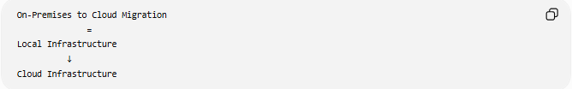
On-Premises to Cloud Migration
=
Local Infrastructure
↓
Cloud Infrastructure

📚 What is On-Premises Infrastructure?
# Source: AI Source: Provided by: [Data Path: Persons Table -> ID Column: 1, Name_En Column: Motasem Essam] -> From: [ChatGPT] on [6/7/2026]
On-premises infrastructure is IT equipment owned by the organization.
Example:
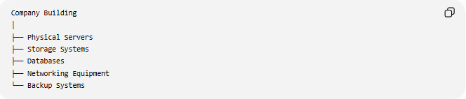
Company Building
│
├── Physical Servers
├── Storage Systems
├── Databases
├── Networking Equipment
└── Backup Systems
The company is responsible for:
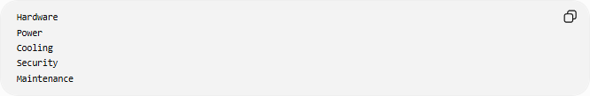
Hardware
Power
Cooling
Security
Maintenance

🔍 Migration Overview
# Source: AI Source: Provided by: [Data Path: Persons Table -> ID Column: 1, Name_En Column: Motasem Essam] -> From: [ChatGPT] on [6/7/2026]
Before
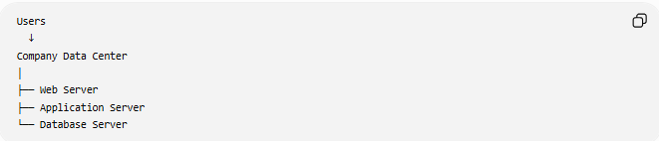
Users
↓
Company Data Center
│
├── Web Server
├── Application Server
└── Database Server

After
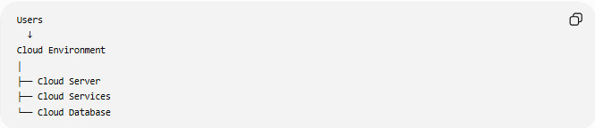
Users
↓
Cloud Environment
│
├── Cloud Server
├── Cloud Services
└── Cloud Database

🏗️ What Can Be Migrated?
# Source: AI Source: Provided by: [Data Path: Persons Table -> ID Column: 1, Name_En Column: Motasem Essam] -> From: [ChatGPT] on [6/7/2026]
Servers
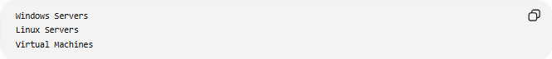
Windows Servers
Linux Servers
Virtual Machines

Applications
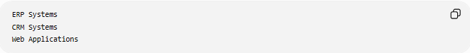
ERP Systems
CRM Systems
Web Applications

Databases
- MySQL
- PostgreSQL
- Microsoft SQL Server
- Oracle Database

Files and Storage
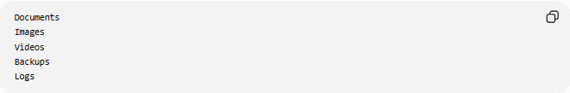
Documents
Images
Videos
Backups
Logs

Network Services
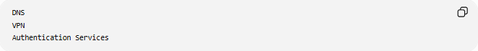
DNS
VPN
Authentication Services

🛠️ Real-World Example
# Source: AI Source: Provided by: [Data Path: Persons Table -> ID Column: 1, Name_En Column: Motasem Essam] -> From: [ChatGPT] on [6/7/2026]
Before Migration
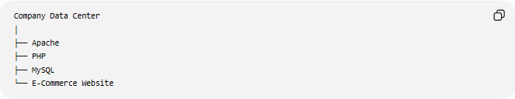
Company Data Center
│
├── Apache
├── PHP
├── MySQL
└── E-Commerce Website
Problems:
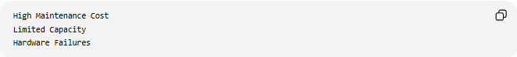
High Maintenance Cost
Limited Capacity
Hardware Failures

Migration
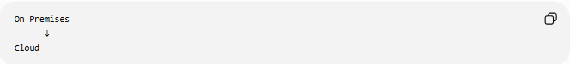
On-Premises
↓
Cloud

After Migration
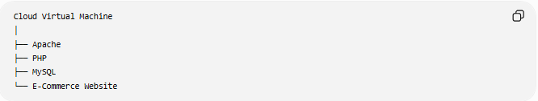
Cloud Virtual Machine
│
├── Apache
├── PHP
├── MySQL
└── E-Commerce Website
Benefits:
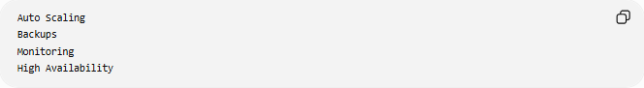
Auto Scaling
Backups
Monitoring
High Availability

🔄 Cloud Migration Strategies (6 Rs)

1️⃣ Rehost (Lift and Shift)
# Source: AI Source: Provided by: [Data Path: Persons Table -> ID Column: 1, Name_En Column: Motasem Essam] -> From: [ChatGPT] on [6/7/2026]
Move workloads with minimal changes.
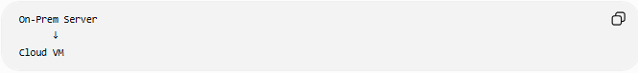
On-Prem Server
↓
Cloud VM
Fastest migration method.

2️⃣ Replatform
# Source: AI Source: Provided by: [Data Path: Persons Table -> ID Column: 1, Name_En Column: Motasem Essam] -> From: [ChatGPT] on [6/7/2026]
Make small optimizations during migration.
Example:
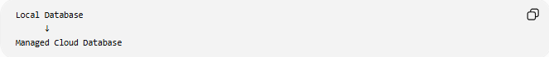
Local Database
↓
Managed Cloud Database

3️⃣ Refactor (Re-Architect)
# Source: AI Source: Provided by: [Data Path: Persons Table -> ID Column: 1, Name_En Column: Motasem Essam] -> From: [ChatGPT] on [6/7/2026]
Redesign applications for cloud-native architecture.
Example:
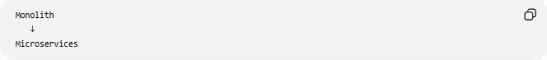
Monolith
↓
Microservices

4️⃣ Repurchase
# Source: AI Source: Provided by: [Data Path: Persons Table -> ID Column: 1, Name_En Column: Motasem Essam] -> From: [ChatGPT] on [6/7/2026]
Replace software with a cloud SaaS solution.
Example:
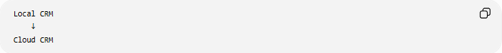
Local CRM
↓
Cloud CRM

5️⃣ Retire
# Source: AI Source: Provided by: [Data Path: Persons Table -> ID Column: 1, Name_En Column: Motasem Essam] -> From: [ChatGPT] on [6/7/2026]
Remove unused applications.
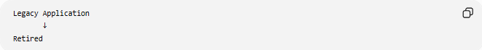
Legacy Application
↓
Retired

6️⃣ Retain
# Source: AI Source: Provided by: [Data Path: Persons Table -> ID Column: 1, Name_En Column: Motasem Essam] -> From: [ChatGPT] on [6/7/2026]
Keep some systems on-premises.
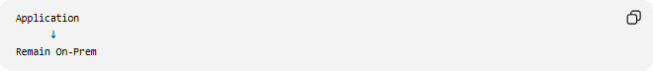
Application
↓
Remain On-Prem

🌍 Example Architecture
# Source: AI Source: Provided by: [Data Path: Persons Table -> ID Column: 1, Name_En Column: Motasem Essam] -> From: [ChatGPT] on [6/7/2026]
Before
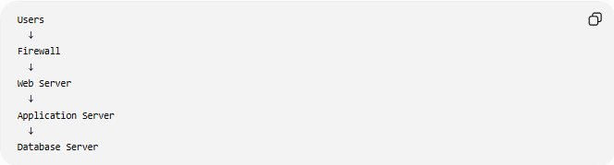
Users
↓
Firewall
↓
Web Server
↓
Application Server
↓
Database Server

After
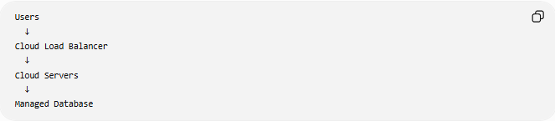
Users
↓
Cloud Load Balancer
↓
Cloud Servers
↓
Managed Database

☁️ Common Cloud Services Used
# Source: AI Source: Provided by: [Data Path: Persons Table -> ID Column: 1, Name_En Column: Motasem Essam] -> From: [ChatGPT] on [6/7/2026]
Compute
Cloud servers that run applications.
Examples:
- Amazon Web Services EC2
- Microsoft Virtual Machines

Storage
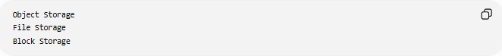
Object Storage
File Storage
Block Storage

Managed Databases
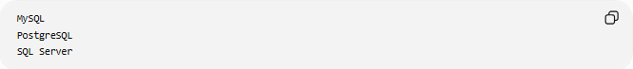
MySQL
PostgreSQL
SQL Server
without managing database servers manually.

Networking
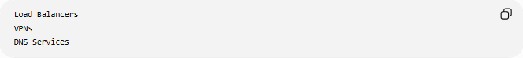
Load Balancers
VPNs
DNS Services

⚠️ Common Challenges
# Source: AI Source: Provided by: [Data Path: Persons Table -> ID Column: 1, Name_En Column: Motasem Essam] -> From: [ChatGPT] on [6/7/2026]
Data Transfer
Organizations may have:
TBs or PBs of Data
to move.

Downtime
Some applications may require maintenance windows.

Security and Compliance
Sensitive information must remain protected.

Application Compatibility
Some applications depend on:
Specific Hardware
Legacy Software

Cost Management
Cloud resources must be monitored to avoid overspending.

✅ Benefits
# Source: AI Source: Provided by: [Data Path: Persons Table -> ID Column: 1, Name_En Column: Motasem Essam] -> From: [ChatGPT] on [6/7/2026]
No Hardware Management
No Physical Servers
No Data Center Maintenance

Scalability
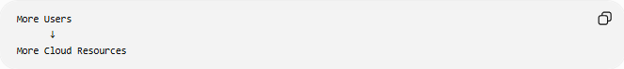
More Users
↓
More Cloud Resources

High Availability
Automatic Failover
Redundancy

Disaster Recovery
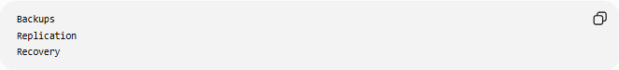
Backups
Replication
Recovery

Global Access
Worldwide Availability

Faster Deployment
New servers can be created in minutes.

📊 On-Premises to Cloud vs Physical-to-Cloud
# Source: AI Source: Provided by: [Data Path: Persons Table -> ID Column: 1, Name_En Column: Motasem Essam] -> From: [ChatGPT] on [6/7/2026]
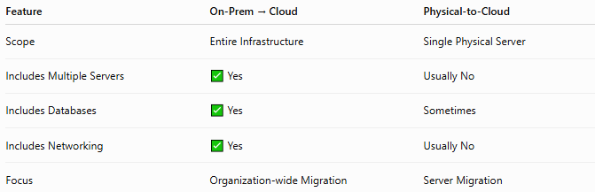
Feature | On-Prem → Cloud | Physical-to-Cloud
Scope | Entire Infrastructure | Single Physical Server
Includes Multiple Servers | ✅ Yes | Usually No
Includes Databases | ✅ Yes | Sometimes
Includes Networking | ✅ Yes | Usually No
Focus | Organization-wide Migration | Server Migration

Physical-to-Cloud
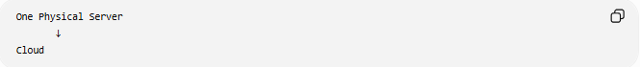
One Physical Server
↓
Cloud

On-Premises to Cloud
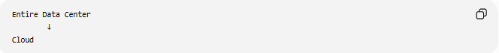
Entire Data Center
↓
Cloud

🛠️ Common Migration Tools
# Source: AI Source: Provided by: [Data Path: Persons Table -> ID Column: 1, Name_En Column: Motasem Essam] -> From: [ChatGPT] on [6/7/2026]
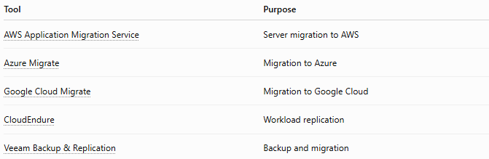
Tool | Purpose
AWS Application Migration Service | Server migration to AWS
Azure Migrate | Migration to Azure
Google Cloud Migrate | Migration to Google Cloud
CloudEndure | Workload replication
Veeam Backup & Replication | Backup and migration

🧠 Simple Analogy
# Source: AI Source: Provided by: [Data Path: Persons Table -> ID Column: 1, Name_En Column: Motasem Essam] -> From: [ChatGPT] on [6/7/2026]
Imagine a company owns its own office building.
Before
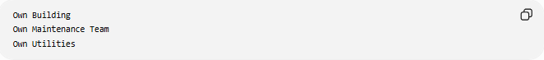
Own Building
Own Maintenance Team
Own Utilities

After
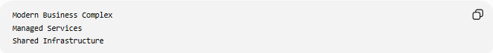
Modern Business Complex
Managed Services
Shared Infrastructure
The company still operates normally but no longer manages the building itself.
On-Premises to Cloud migration works similarly:
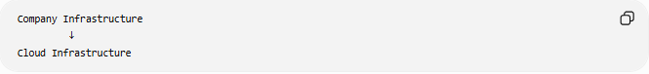
Company Infrastructure
↓
Cloud Infrastructure
while keeping applications and services available.

🧭 Summary
# Source: AI Source: Provided by: [Data Path: Persons Table -> ID Column: 1, Name_En Column: Motasem Essam] -> From: [ChatGPT] on [6/7/2026]
On-Premises to Cloud Migration is a type of server migration in which an organization moves its servers, applications, databases, storage, and networking services from local infrastructure to cloud platforms such as Amazon Web Services, Microsoft, or Google. Unlike Physical-to-Cloud migration, which focuses on a single server, On-Premises to Cloud migration often involves migrating an entire data center or IT environment to the cloud to gain scalability, high availability, lower maintenance costs, and improved disaster recovery capabilities.

